ACE Directions and ACE Rocket Fuel Tablets Directions

ACE must never be X-Ray’ed or irradiated therefore when you are travelling always wrap it in aluminum foil and when you are sending thru the mail – wrap it in aluminum foil. This is how I travel with my ACE.

Never want to get grey hair???? Take ACE… if you have gray hair already, 3 years on ACE and you will have NONE! PURE 100% Ionic Minerals, perfect spin on them, so that body sees them as food… ONE DROP WILL LIGHT A LIGHT BULB! They will enhance any supplement they are put with because of their nature, making them ultra powerful.

Therapeutic Recommended Amount:
You are to take ACE at the rate 40 drops per 150 lbs of body weight, divided up at least 2 times in the day, that is, 20 drops morning at night, or 10 drops 4x/day or 5 drops 8x/day – you get the idea, the point is this: the more you split it up the more powerfully it works, however, this is nothing new, this is a common occurrence in ALL nutrition products in the world! 2x/day for this one is enough.

To start on ACE and build yourself up, you are to start with about 10 drops morning and night or less. Add one drop each day until you are at the recommended amount for your body weight… Therefore, for day one you will do 10 drops morning and night, and next day 11 drops morning and night, and next day 12 drops morning and night until you have reached a total for the day of 40 drops for the entire day per 150 lbs of body weight. The purpose of this building up period is because if you take too much too soon you will have diarrhea for a few days, this is perfectly fine and has NO ill affect on the body - but if you’d rather not ever have diarrhea, then slow down and take smaller amounts til you have built yourself up to the right amount slowly, no worries whichever way you choose though!

ACE can also be applied externally as well, I recommend everyone do that for the first 6 months – Note also: the founder and her father, one of the inventors of this, used to use this in his scalp and rub it in every single night…. It will make skin shine when it is applied to the skin, especially if you apply it by putting say 2 tbl of ACE into a quart of coconut oil and rub some coconut oil all over your skin every morning after you dry off out of the shower. For the ladies, your husbands will tell you how amazingly soft your skin is if they don’t already do this…Be sure to avoid cut and scratches as ACE will irritate those areas for about 10 minutes.

Maintenance recommended amounts:
Half the amount above, to be taken for life….

A lot of people take this supplement for no other reason than to make sure they never have grey hair their entire lives! Haha! This is pure Ionic Minerals that the body sees as food, so that one drop of this stuff is enough to light a light bulb! It’s that Alive! Also, if you have grey hair already, then 3 years of taking this at therapeutic level will remove all your grey hair, and then you can return to regular maintenance amount so that you do not get grey hair ever again…

ACE Rocket Fuel Tablets

Many people take these for no other reason than endless energy pick up thru the day maybe taking one in morning and one in afternoon, or one at 8am, 11am, and 230pm… but do not take it after 6pm as it might keep you up too late and that would not be good.

Others take this as their ONLY diet pill as it will remove water weight gain amazingly affectively, in fact, you will urinate more out of your body than you take in in liquids starting the first day but you’ll have to follow these directions:

When using this as a diet aid for removal of water weight gain primarily and body fat secondarily, take one tablet every 1 or 2 hours for 6 tablets per day for the entire month.
You can keep it up at this rate for as long as you see results this good, but if you would like to save some money then starting in 2nd month you can try cutting it down to only 1 tablet every 2 or 3 hours so only taking 4 tablets per day or so.

Those are both good therapeutic amounts that will remove water weight gain and some fat gain… and give you back energy as a great side effect.

Others take these as a multivitamin instead. It has many different uses.

ACE – More info

One of the stories from the founder was from when she was younger in 1992and her 91 year old grandmother was dying, and the founder’s brother gave her a call along with her mom, and told her that they did not think grandma would live thru the next day. But the founder, the granddaughter, had other plans! She drove all night thru the snow to get to town early in the morning, bought about a ½ gallon of Cranberry Juice because grandmother loved it and then proceeded to put a lot of ACE in it! (she did NOT know nor pay attn to how much ACE she put in only that she put in a LOT!) She knew her grandmother loved cranberry juice and that she needed something to cut the taste of the ACE to make it palatable and cranberry works amazingly well for that! sooo, that’s exactly what she did! She arrived home and proceeded to give her grandmother some cranberry with ACE… grandmother was asleep and so she dribbled it in slowly into her mouth with a straw, drop by drop… the body will naturally swallow just like at night when you produce too much saliva, keeping you from drowning from saliva build up, same concept here… The founder continued this on her grandmother for about 30 mins then went to speak to her mom and brother in the other room for a while… about noon time now (few hours later and with both mom and brother) and thinking that she will not walk again nor get up but that the end is soon, → in walks grandmother with her stroller which she has not used for years. Grandmother was NONE TOO PLEASED!!!! LOL You see, she has not been able to do a lot of things around the house like she used to, not the cleaning and running around she was used to in her younger years and she was ready to GO! She tasted a funny taste in her mouth and the first words out of her mouth were – what is this weird taste in my mouth – she recognized it was ACE and instantly yelled out her granddaughter’s name and said, “Granddaughter! I was all ready to go and see God why did you give me that!!!” – to which the granddaughter started laughing, and said, “NO WAYYYY grandmother are you going anywhere!!! Your great grandchildren need to see you and you may be ready to go but we ARE NOT READY FOR YOU LEAVE” as she laughed… well the grandmother lived to 99 years old after that…

Robert von Sarbacher
940-233-0484
Phoenixguy888@gmail.com

ACE is $55 for a 90 day supply taken at rate of drops mentioned above, or 180 day supply if taken on at small maintenance level when nothing is wrong with you, just for prevention purposes and those wishing to never have grey hair in the future, ie, no grey hair for a VERY long time at least God willing!
ACE is $300 per ½ gallon instead of $400…
ACE is $500 per gallon instead of $880 – so a nice discount if order by the gallon at a time. That’s a huge discount and there are larger disounts at 5 and 5+ gallons at a time…

For those who wish to see the amazing and incredible results of using ACE GARDENING FORMULA instead of ACE on plants – you will be amazed at what you are about to see, look at all these photos of those that have used this product! Note : the gardening version is less stringent in purity requirements and sells ONLY by the gallon at a lower price obviously than ACE for humans:
http://www.subtleenergies.com/ormus/tw/ormusplants.htm
this entire site here above is based not on Ormus but instead on ACE version of Ormus ONLY! Are you freaked out yet?
NOTE: THAT IS THE GARDEN ACE VERSION RIGHT THERE, WANT TO ORDER THAT call me I’m at 1-940-233-0484
Finally this is available to the whole world and is 1/8th the cost of pesticides and so much more powerful….and sometimes will double or triple a crop!!! Also will aid in strengthening the plants, hence it’s anti-pest power b/c plants so strong they won’t go near them, b/c one bite and they will die… depending on the pest or how long been using Garden ACE…

The most famous story of all though is the story of King Tut the Cat – it’s the founder’s cat (founder is the woman in the photo below) and that cat had somehow come home with its tail missing! It had been cut off at the root almost! Well, the founder put in 5 drops of ACE in about 1 cup of water in the morning and then empty that cup, and then at about 5pm IF any left in that cup of water, she would put in 5 more drops in that afternoon into another full cup of water or so… actually it probably held about 2 ½ cups if I remember the story right…. this tiny little cat would take to that water like magic, ACE seems to attrack animals to drink water more frequently and in a larger amount, go figure! It does NOT taste good to us Humans haha! After drinking the water, the cat would continually lick it’s stub of a tail, but the cat would constantly lick and lick it after drinking the ACE in water. Well over a period of a few months the cat totally regrew it’s tail, but it was a baby cat only < 6 months old (I think about 2 ½ to 3 months or so months old total) so that has a lot to do with why it regrew a tail, though it couldn’t have regrown it at all without ACE. This story is one of the most famous in ORMUS circles -(ACE if a form of ORMUS which is like a superconcentrate of minerals and such - as all Ormuses are.) -

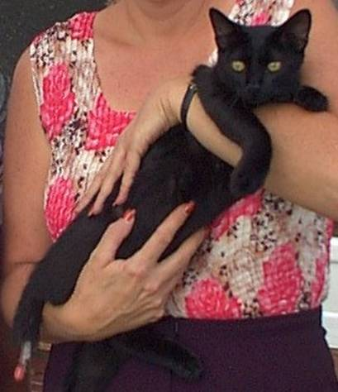
The above picture: This is Tut the cat. Tut was born in April of 2003. This person, Dana, found him on May 23, 2003. He had lost his mommy and was starving. He cried day and night till May 26.

Dana put him on the back porch that evening because his crying was keeping everyone awake. She left the outside door open a bit in case he had to get out.

There was a big storm that night and part of the roof of an outbuilding collapsed. The next morning Tut was sitting on the back step but his tail was almost completely severed. Tut's tail came completely off in a day or so.

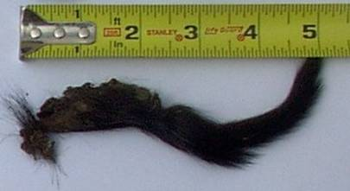
Above picture: is the portion of
Tut's tail that came off.

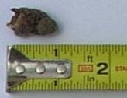

Above Picture: is the scab which
covered the entire remaining
stub of Tut's tail

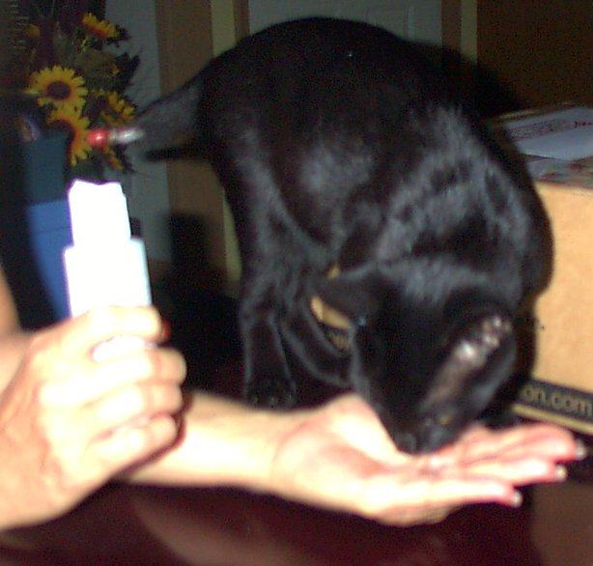
Above picture is the founder feeding TUT directly out of her hand. She’s used an ormus product called Cleopatra’s milk to illustrate that despite this not being for consumption, that the cat would lick it out of it’s hand without measure WHEN the ACE was in the Cleopatra milk (I think it’s a very superior and clean form of facial lotion, not the poisonous filth hydration and facial lotions that are sold in all beauty places as well as walmart lol) Anyway, despite how amazingly awful Cleopatra milk tastes, the cat would still drink it endlessly when ACE was in it!

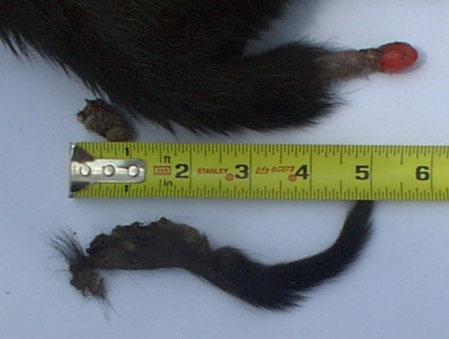
Above picture: you can see how Tut is re-growing his tail. The red tip is the newest segment. Now and then, Dana has seen bone forming at the very end. It has grown about five inches as of August 14, 2003

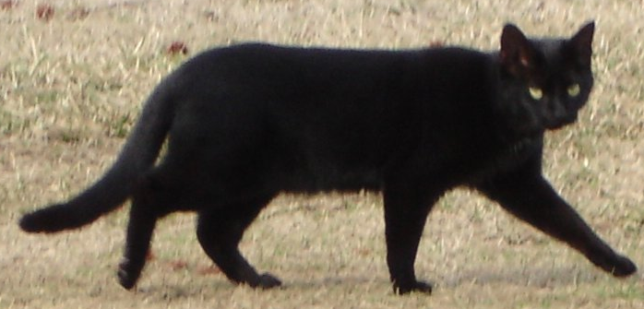
Above Picture taken with Tail fully regrown in 2007 by request from those in the Ormus community!
Many in the Ormus Community are unaware of the magnificent use of ACE on this Cat thinking it was Cleopatra’s Milk or some other Ormus Product! IT WAS NOT… Cleopatra’s milk, another form of Ormus inside a hand lotion if I recall correctly, haha, was simply mentioned as a side note that the cat LOVES that product taste-wise and because it is veryyy tastyif and only with ACE in it, it made it possible to use that to get some extra ACE into Tut in the beginning b/c the cat would lick it up like crazy when ACE was in Cleopatra’s milk, go figure haha! This is fine but the error is corrected for the record as ACE is the only reason this cat regrew it’s tail and the owner of the cat is the founder of the Applied Biophysics Institute, Dana Dudley! The founder used her dad’s formula, ACE, not only on that cat but on her grandmother too when she was younger! (Note: Just for the record: it was her father and a team of scientists all collaborating together that created ACE!!! It is all “their” formula.) ACE is available thru me.

Robert von Sarbacher
940-233-0484
Phoenixguy888@gmail.com

ACE is $55 for a 90 day supply taken at rate of drops mentioned above, or 180 day supply if taken on at small maintenance level when nothing is wrong with you, just for prevention purposes and those wishing to never have grey hair in the future.
ACE is $500 per gallon instead of $880 – so a nice discount if order by the gallon at a time. That’s a huge discount and there are larger disounts at 5 and 5+ gallons at a time…

For those who wish to see the amazing and incredible results of using ACE GARDENING FORMULA instead of ACE on plants – you will be amazed at what you are about to see, look at all these photos of those that have used this product! Note : the gardening version is less stringent in purity requirements and sells ONLY by the gallon at a lower price obviously than ACE for humans:
http://www.subtleenergies.com/ormus/tw/ormusplants.htm
this entire site is based not on Ormus but instead on ACE version of Ormus ONLY! Are you freaked out yet?

